**Team 13**

**SQL Queries for Visualization**

**BR1**

SELECT

f.Source_Data AS City,

COUNT(DISTINCT f.AccidentID) AS TotalAccidents

FROM

Fact_Accidents f

WHERE

f.Source_Data IN ('New york', 'Austin', 'Chicago')

GROUP BY

f.Source_Data;

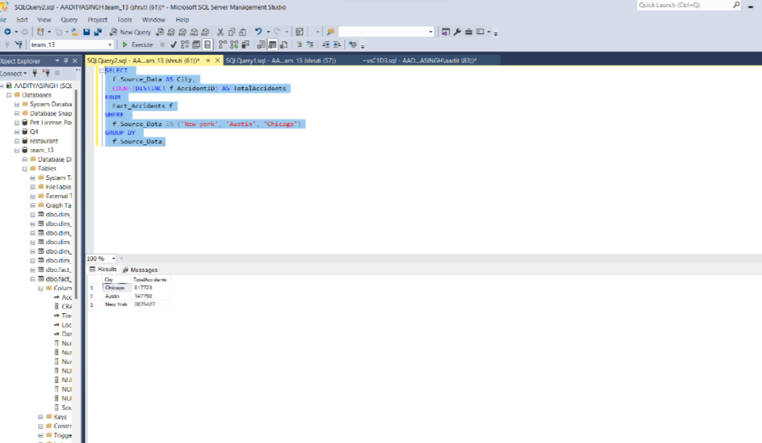

**BR2**

l.City IN ('Austin')

GROUP BY

l.City, l.StreetName

ORDER BY

l.City, AccidentCount DESC -- Using the alias for clarity and brevity

LIMIT 3;  
  
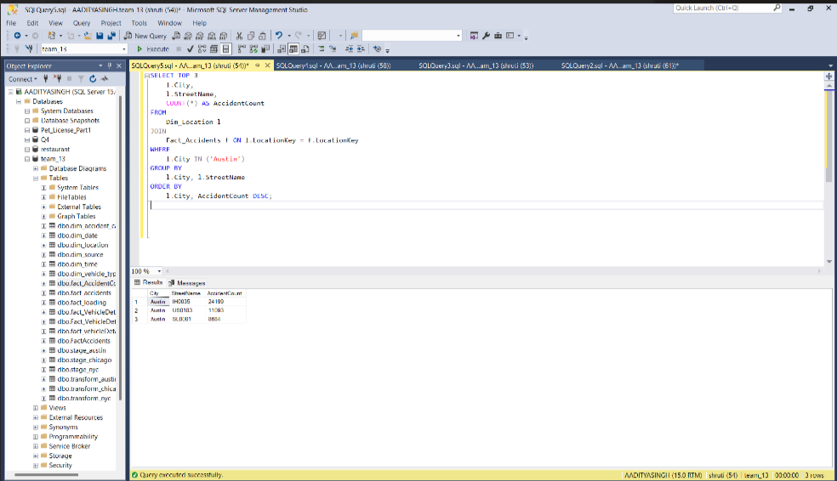

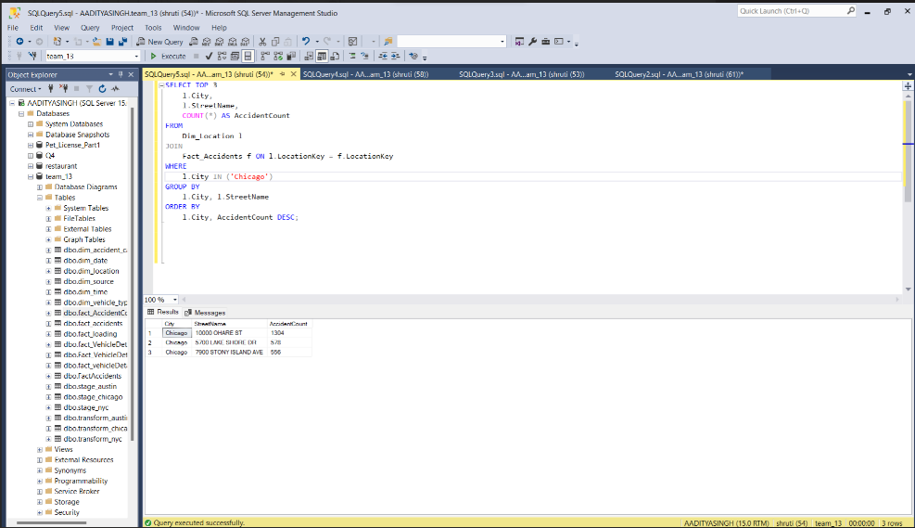

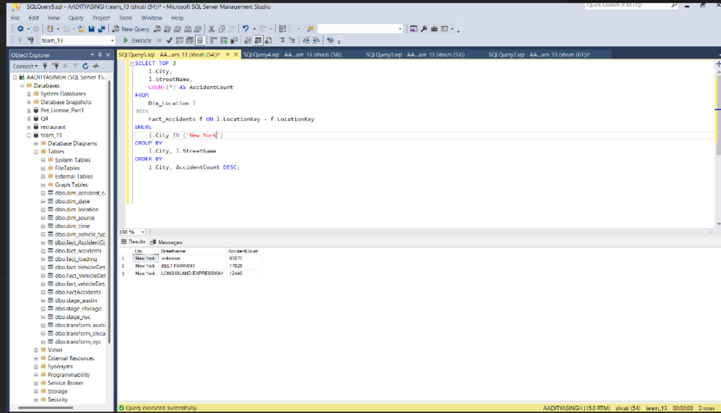

**BR3**

SELECT

f.Source_Data,

SUM(f.Number_Of_Injuries) AS TotalInjuries

FROM

Fact_Accidents f

WHERE

f.Number_Of_Injuries > 0

GROUP BY

f.Source_Data;

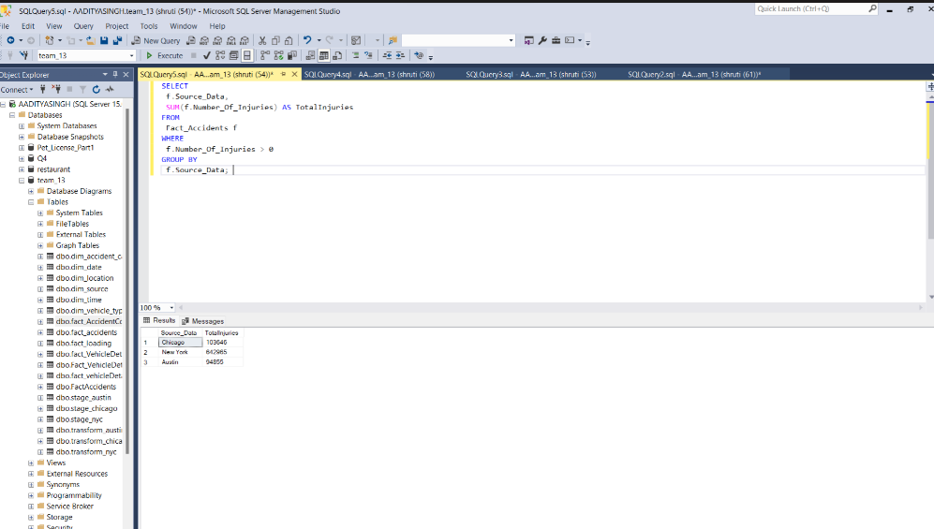

**BR4**

SELECT

COUNT(DISTINCT f.AccidentID) AS PedestrianAccidents

FROM

Fact_Accidents f

WHERE

f.Number_Of_Pedestrians_Injured > 0 OR f.Number_Of_Pedestrians_Killed > 0;

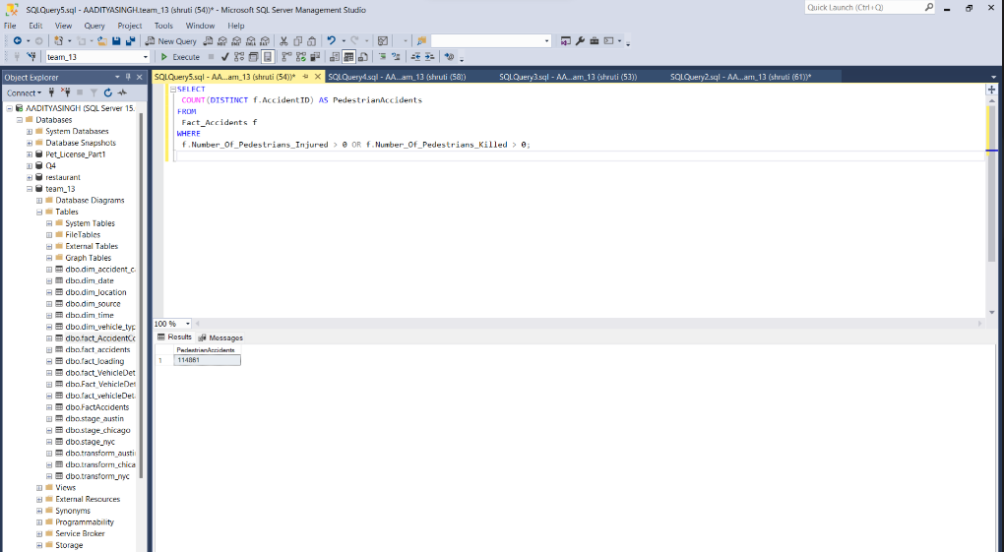

SELECT

l.City,

COUNT(DISTINCT f.AccidentID) AS PedestrianAccidents

FROM

Fact_Accidents f

JOIN

Dim_Location l ON f.LocationKey = l.LocationKey

WHERE

f.Number_Of_Pedestrians_Injured > 0 OR f.Number_Of_Pedestrians_Killed > 0

GROUP BY

l.City;

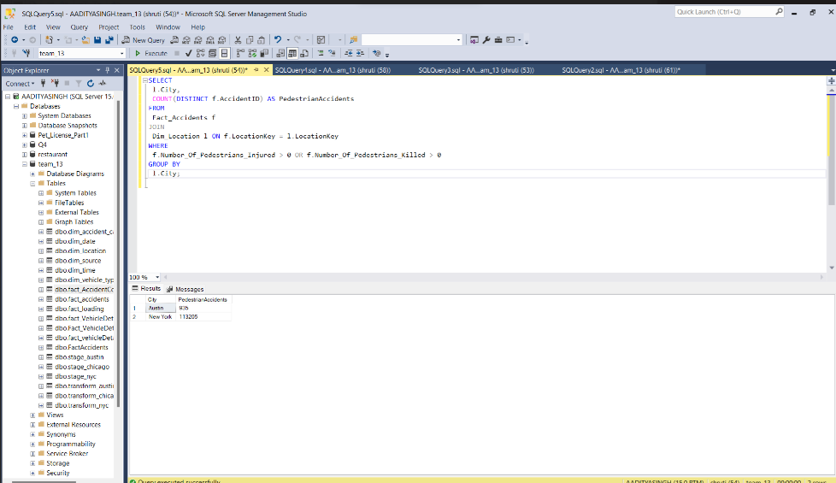

**BR5**

SELECT

d.Month_Num,

COUNT(DISTINCT f.AccidentID) AS Accidents

FROM

Fact_Accidents f

JOIN

Dim_Date d ON f.DateKey = d.DateKey

GROUP BY

d.Month_Num

ORDER BY

d.Month_Num;

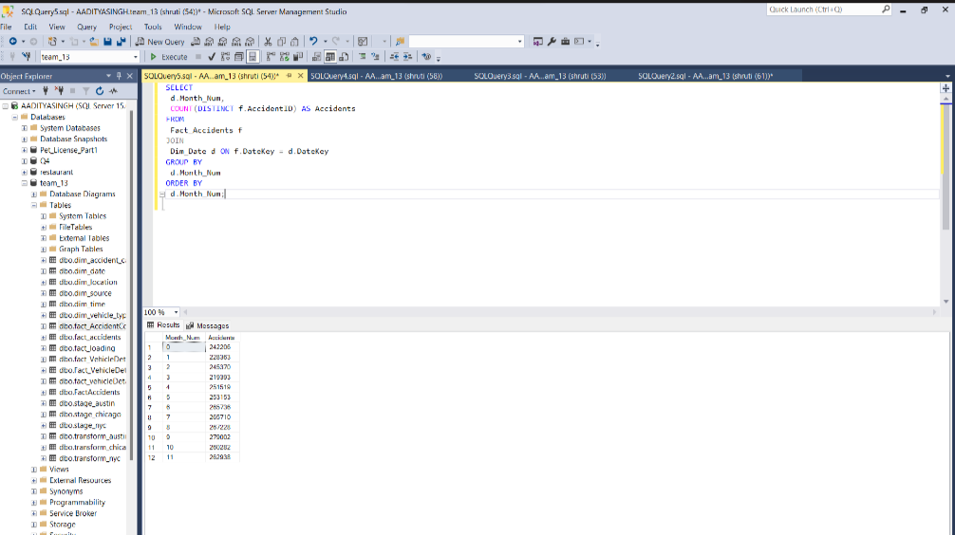

**BR6**

SELECT

SUM(f.Number_Of_Motorist_Injured) AS MotoristsInjured,

SUM(f.Number_Of_Motorist_Killed) AS MotoristsKilled

FROM

Fact_Accidents f;

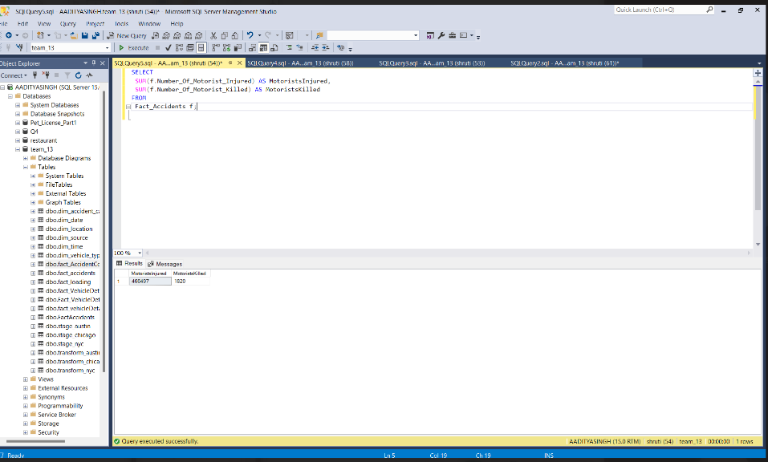

SELECT

l.City,

SUM(f.Number_Of_Motorist_Injured) AS MotoristsInjured,

SUM(f.Number_Of_Motorist_Killed) AS MotoristsKilled

FROM

Fact_Accidents f

JOIN

Dim_Location l ON f.LocationKey = l.LocationKey

GROUP BY

l.City;

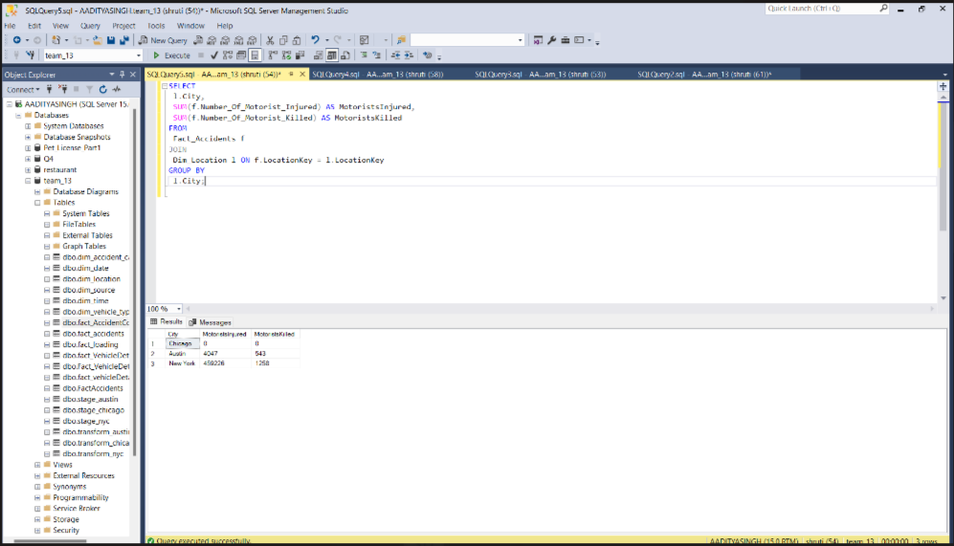

**BR7**

SELECT

f.Source_Data,

SUM(f.Number_Of_Fatalities) AS Fatalities

FROM

Fact_Accidents f

GROUP BY

f.Source_Data

ORDER BY

Fatalities DESC

LIMIT 5;

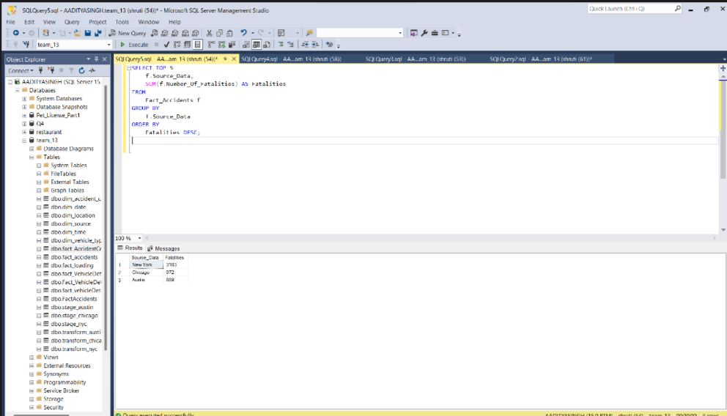

**BR7**

SELECT

l.StreetName,

SUM(f.Number_Of_Fatalities) AS Fatalities

FROM

Fact_Accidents f

JOIN

Dim_Location l ON f.LocationKey = l.LocationKey

WHERE

f.Source_Data = 'Austin'

GROUP BY

l.StreetName

ORDER BY

Fatalities DESC

LIMIT 5;

Austin:

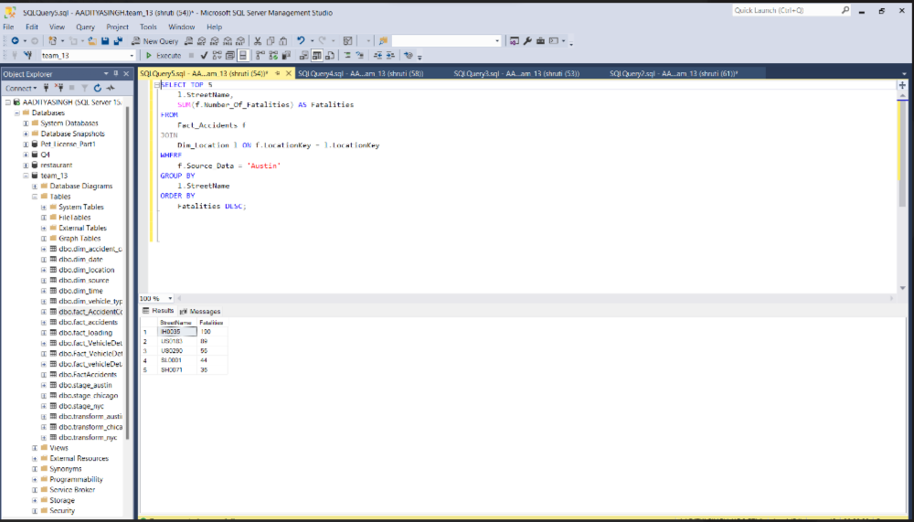

Chicago:

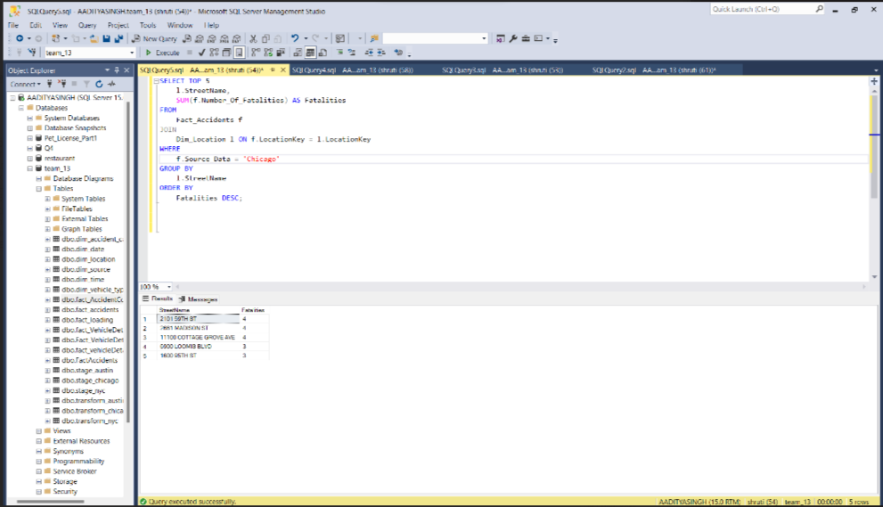

NewYork

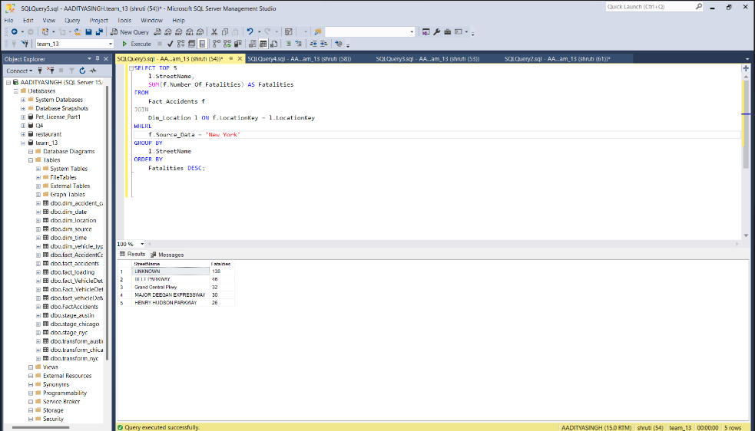

**BR8**

SELECT

t.Hour,

COUNT(DISTINCT f.AccidentID) AS Accidents

FROM

Fact_Accidents f

JOIN

Dim_Time t ON f.TimeKey = t.TimeKey

GROUP BY

t.Hour

ORDER BY

t.Hour;

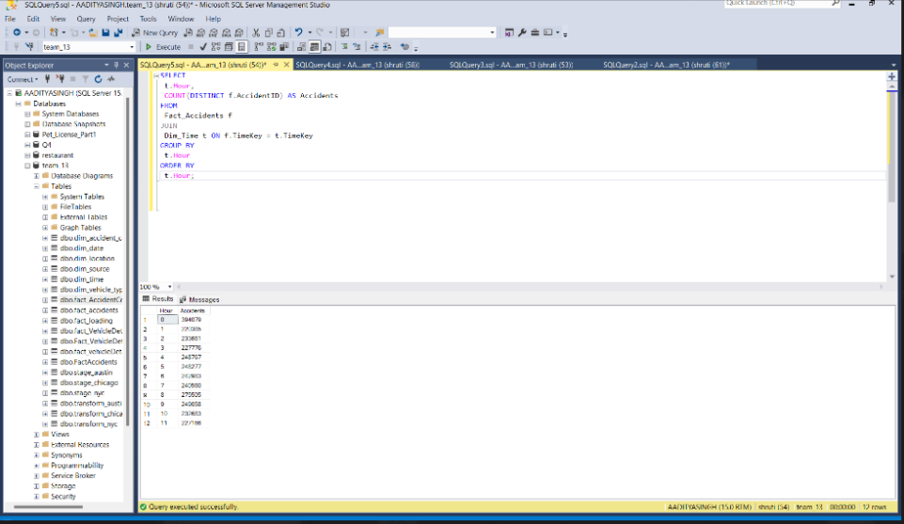

**BR9**

SELECT

SUM(Number_Of_Pedestrians_Killed) AS PedestriansKilled,

SUM(Number_Of_Motorist_Killed) AS MotoristsKilled

FROM

fact_accidents;

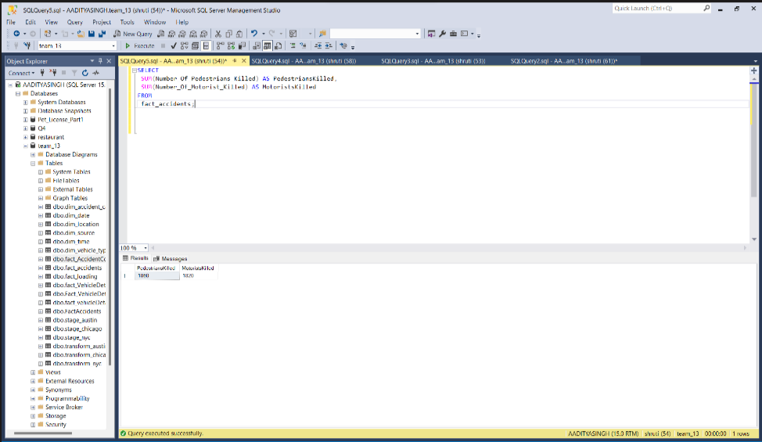

SELECT

SUM(Number_Of_Pedestrians_Killed) AS PedestriansKilled,

SUM(Number_Of_Motorist_Killed) AS MotoristsKilled

FROM

fact_accidents

GROUP BY

Source_Data;

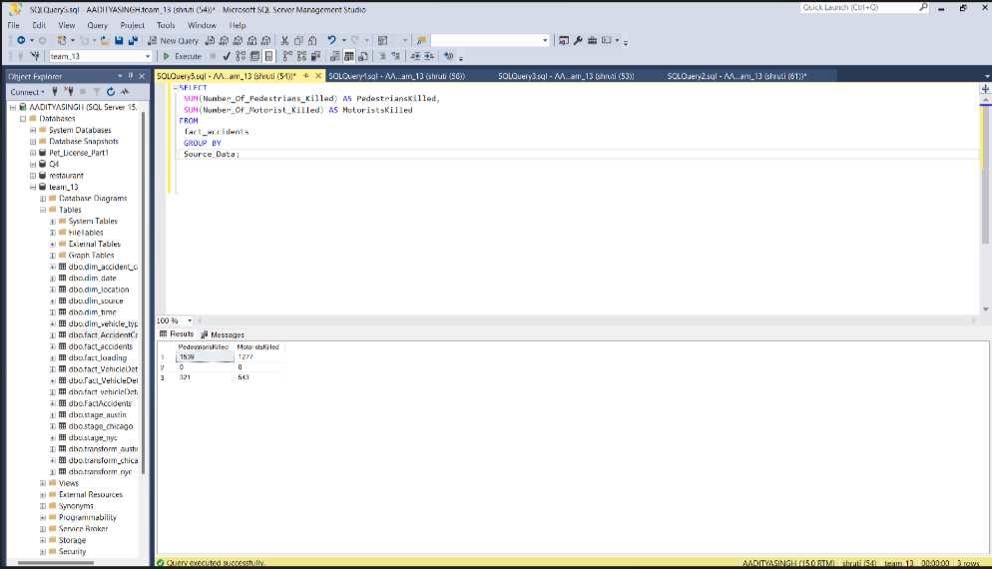

**BR10**

SELECT   
  cause.Description AS ContributingFactor,  
  COUNT(*) AS Occurrences  
FROM   
  fact_AccidentContributors fac  
JOIN   
  dim_accident_cause cause ON fac.Cause_Key = cause.Cause_Key  
GROUP BY   
  cause.Description  
ORDER BY   
  Occurrences DESC;

